School Holiday List 2021/22
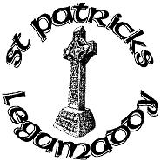
New academic year commences Tuesday 31st August
Term 1
22nd October- 29th October Halloween Holidays
22nd December – 3rd January Christmas Holidays
Term 2
14th-18th February Mid Term Break
17th – 18th March St Patrick’s Day
15th April-22nd April Easter Holidays
Term 3
2nd May May Bank Holiday
30th May – 3rd June Mid-term break
½ day 30th June Summer Holidays

These holidays are in accordance with those harmonised by CCMS, EA Transport and School Meals. We will make every effort to attempt to keep to these days and parents will be notified in good time if any changes are necessary.

