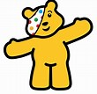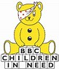
WELL DONE!!!

WE HAVE RAISED A MASSIVE £647 FOR CHILDREN IN NEED!!

AMAZING ON WORLD KINDNESS DAY TOO!!

THANK YOU TO MARY FOR THE LOVELY CUP CAKES.

