School Holiday List 2020/21
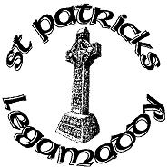
New academic year commences 27th August 2020
Term 1
23rd October- 30th October Halloween Holidays
½ day 21st December Christmas Holidays
22nd December – 5th January Christmas Holidays
Term 2
12th-19th February Mid Term Break
17th March St Patrick’s Day
1st April-9th April Easter Holidays
Term 3
3rd May May Bank Holiday
31st May – 4th June Mid-term break
½ day 30th June Summer Holidays

These holidays are in accordance with those harmonised by CCMS, EA Transport and School Meals. We will make every effort to attempt to keep to these days and parents will be notified in good time if any changes are necessary.

