School Holiday List 2022/23
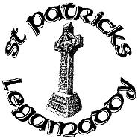
New academic year commences Tuesday 30th August
(all dates are inclusive)
Term 1
28th October- 4th November Halloween Holidays
22nd December – 3rd January Christmas Holidays
Term 2
13th-17th February Mid Term Break
17th March St Patrick’s Day
6th April-14th April Easter Holidays
Term 3
1st May May Bank Holiday
29th May – 2nd June Mid-term break
½ day 30th June Summer Holidays

These holidays are in accordance with those harmonised by CCMS, EA Transport and School Meals. We will make every effort to attempt to keep to these days and parents will be notified in good time if any changes are necessary.

