Sacramental Dates 2024
Primary 7 Service Of Light
Tuesday 23rd January @ 6.30pm

Primary 3 First Penance
Tuesday 12th March @ 1.30pm
Primary 4 First Holy Communion
Saturday 11th May @ 11am
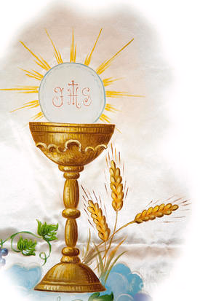

Primary 7 Confirmation
Wednesday 22nd May @ 11am
Event Name

